Basic Spreadsheet Concepts Exercise 7
Type in the following spreadsheet, and format it to look like the sample below.
Instructions
- Type in all text and numbers shown in the spreadsheet below.
Weekly Income Schedule
Date | Expenditure | Refund | Total Expenditure | Income | Profit £
01-Jan | 423.98 | 62 |  | 550
13-Jan | 598.12 | 67.73 |  | 780
20-Jan | 410.45 | 45 |  | 659.9
27-Jan | 499.1 | 33.75 |  | 653.98
03-Feb | 370.25 | 28.12 |  | 583
10-Feb | 440.8 | 56.25 |  | 589.12
17-Feb | 530.25 | 51.75 |  | 695.8
22-Feb | 490.55 | 96.75 |  | 663.6
Totals

2) Format all numbers with appropriate format's).
3) Centre the spreadsheet heading "Weekly Income Schedule" across the spreadsheet.
4) Format all text as displayed in the sample below.
5) Create formula's to display a total for each item in the Lunch Bar.
6) Create formula's to calculate the Total Exp (Total Expenditure).
7) Create formula's to calculate the profit.
8) create formula's to calculate the totals for each column.
9) Apply all borders and shading (colour) shown in the sample below, feel free to experiment with your own colour schemes.

Basic Spreadsheet Concepts Exercise 7 Model Answer

The following spreadsheet is an example of how your spreadsheet should look, you can feel free to try different colour combinations.
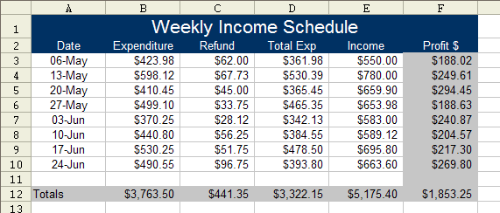
The following spreadsheet shows the formula's you need to complete the spreadsheet.
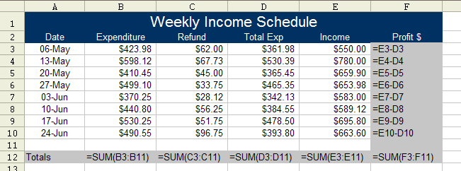
Note 1: The total expenditure is equal to the expenditure minus the refund, i.e. B3-C3.
Note 2: The profit is equal to the income minus the total expenditure, a negative profit value is a loss.

